**STEPS TO CREATE REAL ESTATE DASHBOARD**

1: Open **Tableau Public**  
2: On the home page, under Connect, under to a file, click Excel.  
3: Browse and connect to the **Real_Estate Excel file**.  
4: Drag and drop **train** tables to the canvas area.

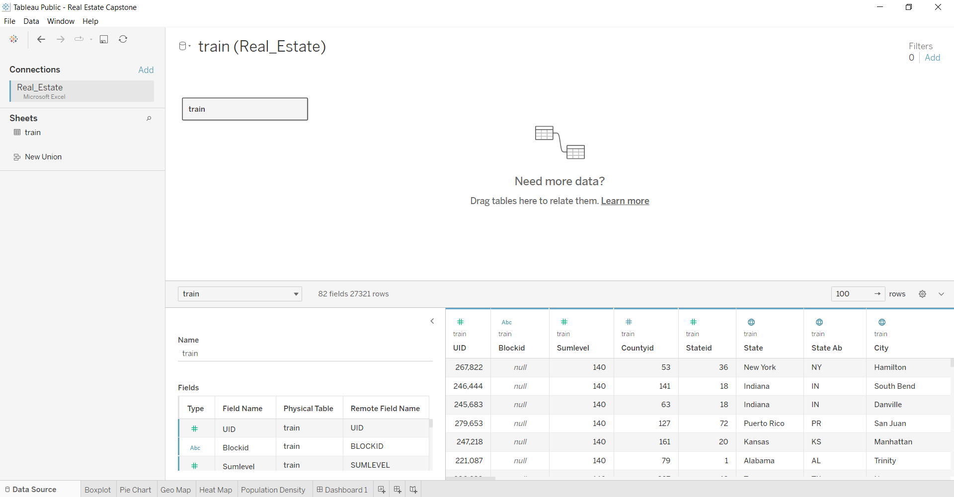

5: Go to Sheet one and rename it as **BOXPLOT**

6: To create a **box plot of the distribution of average rent by type of place (village, urban, town, etc.)**, drag **Type** from the **Real Estate Dataset** and put it on the **Column Shelf,** and then drag **Rent Mean** and put it on the **Row Shelf** and change its **Measures** to **Average**. Finally, drag **the city** and put in **the detail mark card**.

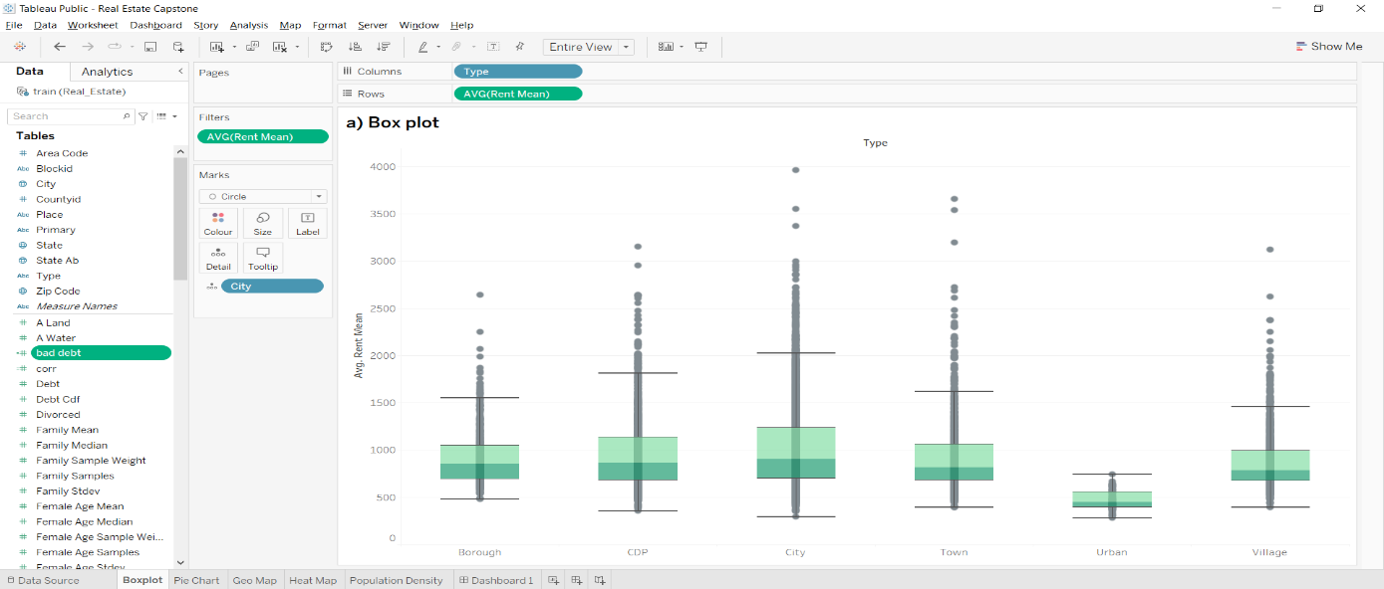

7: To create **a pie chart to show overall debt and bad debt**. Create a calculated field for **bad debt.** Click on **Analysis Pane**, and then **Calculated Field,** and do the following calculation for **bad debt = [**second_mortgage + home_equity - home_equity_second_mortgage**]**. And then change the **Mark Card** option to **Pie,** then **drag** the Measure Name to the **Filters,** then edit the filters and choose the **debt** and **bad debt** dimensions and also drag the Measure Name to **Mark Card Colour**. Drag the Measure Value to the **Mark Card Angle** and then click on Edit Filter and choose the **debt** and **bad debt**. Then drag the **debt** and **bad debt** measure values and put them on the **Mark Card Text**.

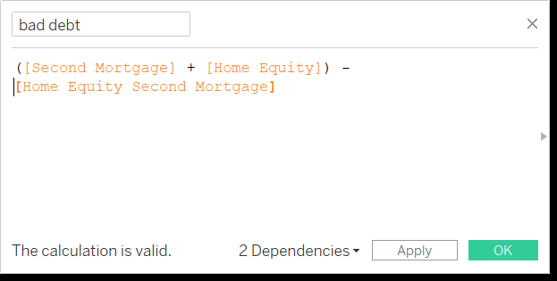

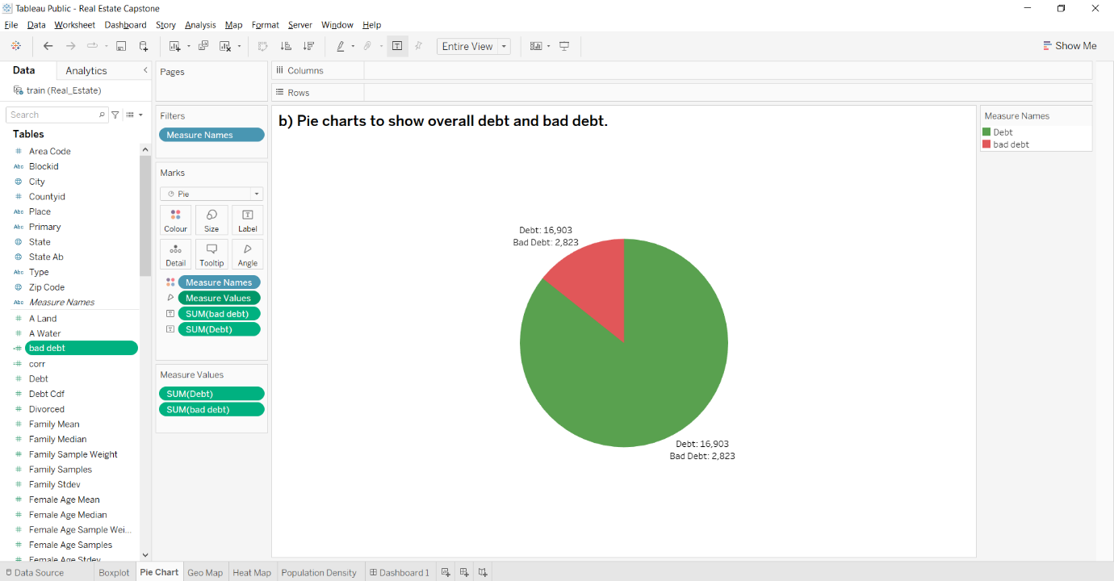

8: To create the **top 2,500 locations where the percentage of households with a second mortgage is the highest and percent ownership is above 10 percent and visualize using geo-map**. Drag the **state** and put it on **Mark Card Detail, Colour, and Label** and then go to automatic and click map. And then drag **Countryid** to **Filters** and select from the list and then go to the Top option, then choose the **By field** and choose the Top option and change the value to 2,500, then change the **by** option to **Second Mortgage** and then click on show filter.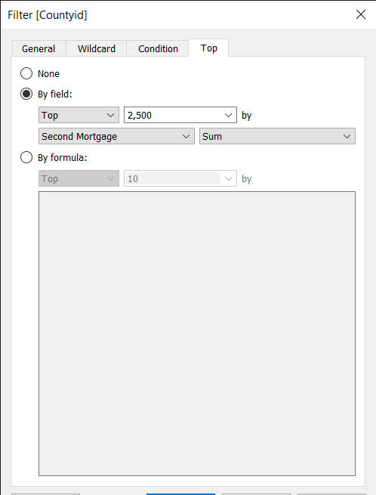

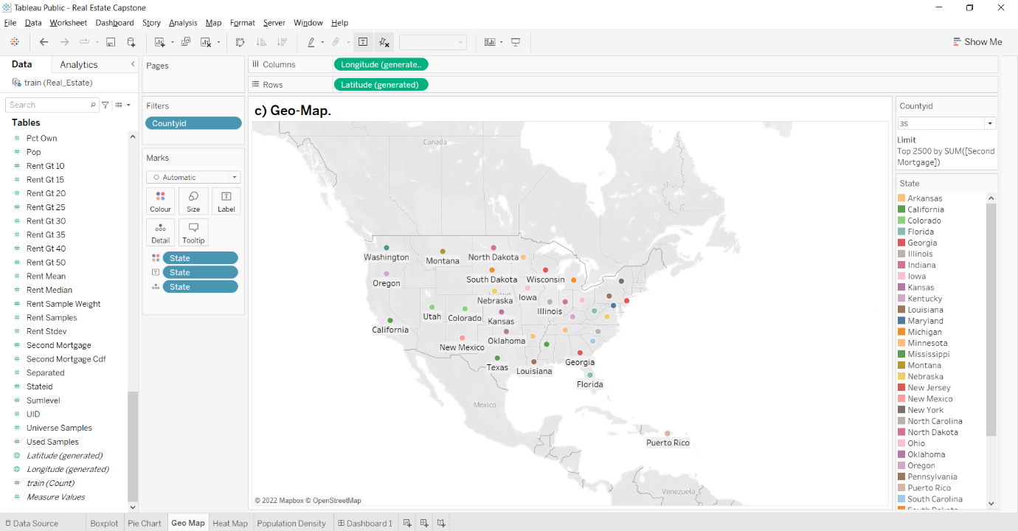

9: To create **Heat map for the correlation matrix**. Create a calculated field for **corr.** Click on **Analysis Pane**, and then **Calculated Field,** and do the following calculation for corr = CORR ([Family Mean], [Rent Mean]). And then drag **Type** and put it on **Columns Shelf**, then drag the **State** and put it on **Rows Shelf**. Drag the **corr** and put it on **Mark Card Colour**. Finally, drag the **countryid** and put it on **Filters**.

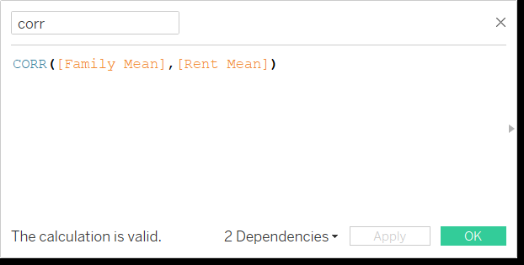

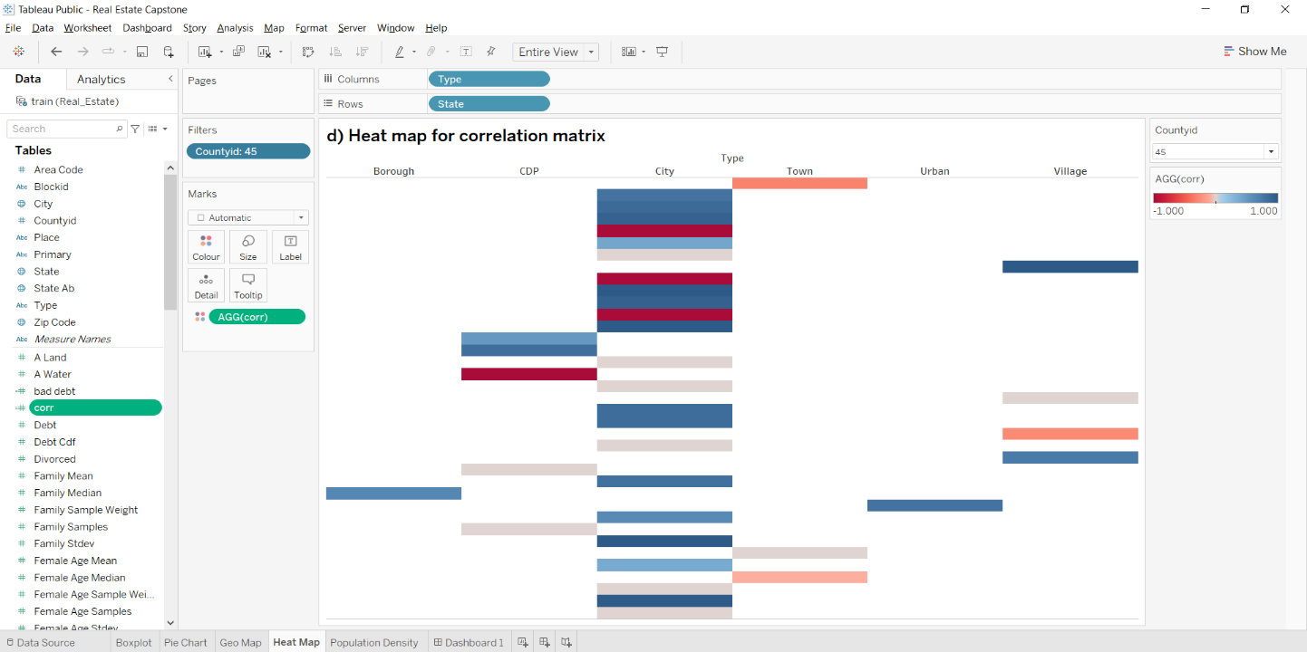

10: To create **a pie chart to show the population distribution across different types of places (village, urban, town, etc.)**. And then change the **Mark Card** option to **Pie, then drag Type and put it on Mark Card Colour and Label. And then drag pop and put it on Mark Card Size, Angle, and Label.**

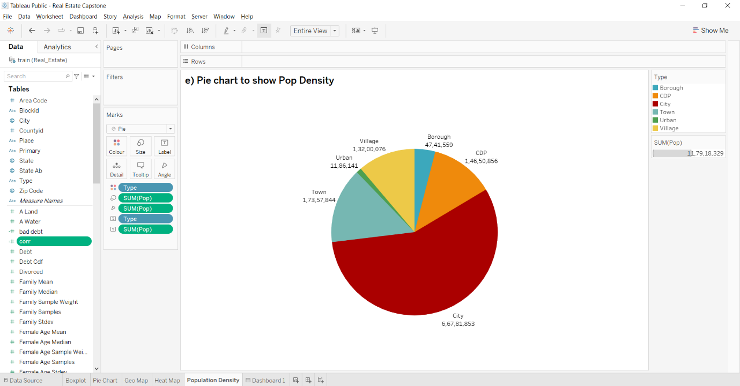

11: Create a Dashboard: Click on the Dashboard button and rename it "**Real Estate Dashboard."**

Go to Size and click Automatic.

Go to Objects and click on Vertical, and then Horizontal. Drag **Geo-Map, A Pie Chart to Show Overall Debt and Bad Debt, A pie chart to show population density, Heat map for correlation matrix and box plot** to sheet.

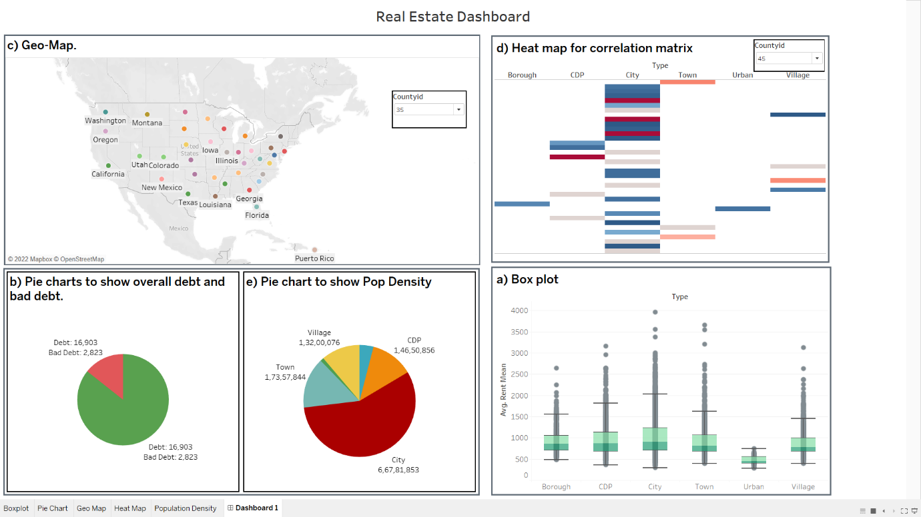

Click This Link to View Viz: [**Dashboard Link**](https://public.tableau.com/views/RealEstateCapstone_16663312397480/Dashboard1?:language=en-US&:display_count=n&:origin=viz_share_link)